Every Tuesday 10 am-2 pm
1st Wed. evening each month 4:30-6:30 pm
1st & 3rd Saturday each month 10 am-12 pm
Free Client Shopping by appointment

To make a Donation or become a
Wish-grantor, Sponsor or Volunteer
GIVE US A CALL.
Phone: 302-698-1900

Address: PO Box 415, Camden, DE 19934
Location: 1309 Ponderosa Drive
Magnolia (warehouse next to
Jonathan’s Landing Golf Clubhouse)
Directions

Directions to office and warehouse:
From Dover: Take South State Street Extension south toward Magnolia. Take a left on Ponderosa Drive (halfway between Rising Sun and Magnolia).
Follow Ponderosa Drive until you see the club house for Jonathan Landing Golf Club at the corner of Golf Link Road. Take a left on Golf Link Road and then a right into the end of the parking lot. Our warehouse is on the left. There is a large sign over the door.
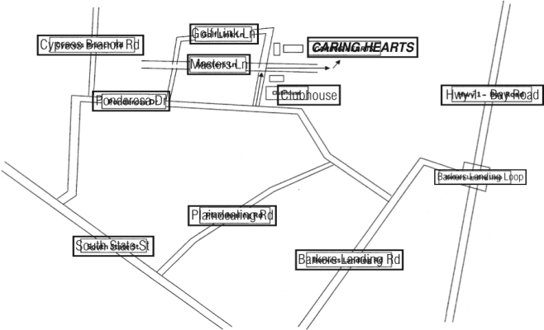

Caring Hearts Helping Hands, Inc.
P.O. Box 415
Camden-Wyoming, DE 19934
Office and
Warehouse Hours

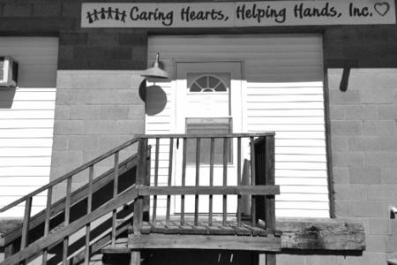

302-698-1900

Check out our Website: chhhde.org
Email: caringheartsde@gmail.com
Follow us on Facebook

We always need:
Wish Granters
Donations
Volunteers

Caring Hearts Helping Hands, Inc.
Is a non-profit (501[3]c) organization, that was incorporated in 2002, staffed entirely by volunteers, supporting financially challenged, working families in Kent County, DE. who could use some assistance throughout the year by allowing them to shop (free of charge) in the warehouse for donated new and gently-used items.
CHHH also has Christmas and Back to School (Heart and Sole) programs. Client families are matched with wish-grantors who support the family for the Christmas/holiday program. CHHH will gratefully receive monetary donations, new and gently used items and welcome volunteers.
Monetary donations  may be made directly to Caring Hearts Helping Hands, Inc. and are tax deductible. | Wish-Grantors  may personally shop for gifts for their family or we will be happy to have a volunteer shop for the wish-grantor. We try to ensure that each child receives at least a new gift or toy and clothes as needed. | Heart & Sole (Back-to-School) each school-age child receives a new book bag filled with appropriate school supplies and a gift card for a new pair of school shoes.  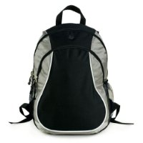 | Donations  We accept new and gently used shoes, children’s clothing, toys, books, domestics, household items (including beds, tables, chairs, dressers, and small appliances), school supplies, personal hygiene items, cleaning supplies and paper products.
Help us help others by getting involved by becoming a wish-grantor, volunteer, or donating gently-used or new household items, furniture or children’s clothing. If you contribute to United Way or the State Employee Charitable Campaign, you can write-in our agency’s code number 12803. If you shop Redner’s Market, send us your receipts.

Family Referrals
New client families are accepted at any time during the year prior to the end of September. Referrals often come from school personnel, homeless shelters, and organizations such as Child, Inc., People’s Place, and Shepherd Place. Self-referrals are also accepted.
Client applications must be fully completed, signed by the client and submitted with proof of employment (pay stub) and a picture ID for any adults in the family unit.
Applications are reviewed and approved by the Board of Directors at their monthly meetings.

Requirements for Clients
- The family must reside in Kent County, DE.
- The family must be able to provide proof of residency and photo identification showing address of residency.
- At least one dependent minor child must be part of the family.
- At least one adult within the family must be employed and is required to provide a copy of his/her latest two pay stubs for proof of employment. Pay stubs must reflect correct address.
- The family may not currently be receiving public (government subsidies, including unemployment) assistance (except for Medicaid and/or Food Stamps) and may not be the recipient of any other holiday help (i.e. The Salvation Army, Toys for Tots, Adopt-a-Family, etc.).
- The family must update their application and re-qualify twice annually.
- The family must demonstrate a genuine need for help by detailing their personal situation.

All information is kept strictly confidential.

H o w t o G e t I n v o l v e d :
Heart & Sole Deadlines  Client Applications ............. Jul 16  Gift Drop-off ..................... Jul 23  Client Pick-up ....... Aug 13, 14, 17  Closed December 14–January 7 | 2024  Christmas Deadlines  New / Reactivate ..................... Sep 30  Active Client Applications .......... Nov 5  Gift Drop-off ............................Dec 7  Client Pick-up ............... Dec 10, 11, 14

